|  |
| --- |
| VITAL EDUACTION PTY LTD |
| USER DOCUMENT |
| By - DIGITIZER |
|  |
| VERSION – 1.0 |
| 10/1/2015 |

|  |
| --- |
| This user document serves as a reference for the users of Vital Education Online System to use the website and access the courses available in the Vital Education Moodle system |

Table of Contents

SYSTEM OVERVIEW 2

GETTING STARTED 3

REGISTER TO THE SYSTEM 3

LOGIN TO THE SYSTEM 4

BOOK A COURSE: 5

CHOOSE TIMETABLE 6

SEARCH TIMETABLE 6

MAKE A PAYMENT 7

MOODLE ACCESS 8

UPDATE PROFILE 8

ACCESS BLOG AND COMMENT TO AN ARTICLE 9

MAKE AN ENQUIRY 10

# SYSTEM OVERVIEW

Vital Education Web System provides the users with an interactive web system for managing their educational needs. It systematically managed application which provides systematic approaches to manage their courses. It is equally helpful for education providers to manage their course contents and students. So it is very useful system for education purposes.

This document provides the users of Vital Education an ease to book the courses and access the online course contents in the Moodle. It intends to give the users a detailed step by step guidance to achieve their desired task in the web system.

# GETTING STARTED

## REGISTER TO THE SYSTEM

Any new user can register to the Vital Education web system. The user needs to provide all the necessary details shown in the below picture to the system to complete the registration process successfully. Once the user completes the registration process, an email will be sent to the provided email address with the user identification number which is required to login to both Vital Education website and Moodle system.

**Steps to registration**

* Click on the register button in the navigation bar.
* Fill the necessary fields with valid information
* Choose a secure password (minimum eight characters long containing a special character, an alphabet and a number)
* Submit the form to complete the registration.

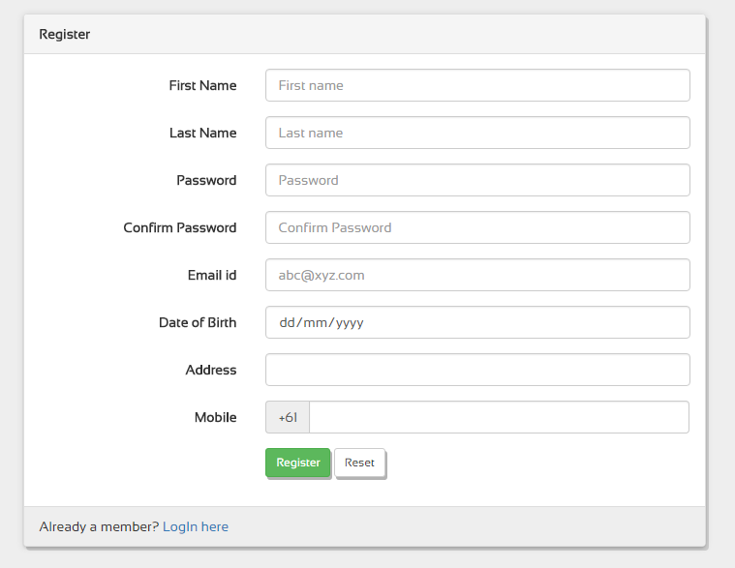

*(fig-1)*

## LOGIN TO THE SYSTEM

After the user gets registered to the system, an email confirmation will be sent to the specified email address which contains user identification number which is required to login to the system. User can login to the system with this user id and the password which was set during the registration process. After logging in to the website, they can access the user profile and their timetable (applicable for the users who enrolled to any course).

**Steps to log-in**

* Click the login button in the navigation bar.
* Enter the user id (sent through email) and password 1.
* Submit the form to log-in.

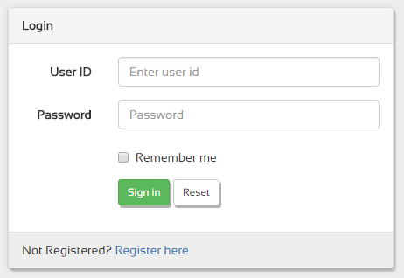

*(fig-2)*

1 - If forgot password, go to the Moodle system and choose forgot password to reset both Vital Education web system password as well as Moodle password.

## BOOK A COURSE:

In order to book a course, the user needs to be logged in to the system. Users can browse the available courses from the ‘Courses’ tab in the navigation bar. All the popular courses are listed in the homepage for the ease of user access.

**Steps to book a course**

* Select desired course from the popular courses section or the list in the navigation bar.
* Check the prerequisites of the course to confirm the eligibility.
* Check the course availability based on the user comfort.

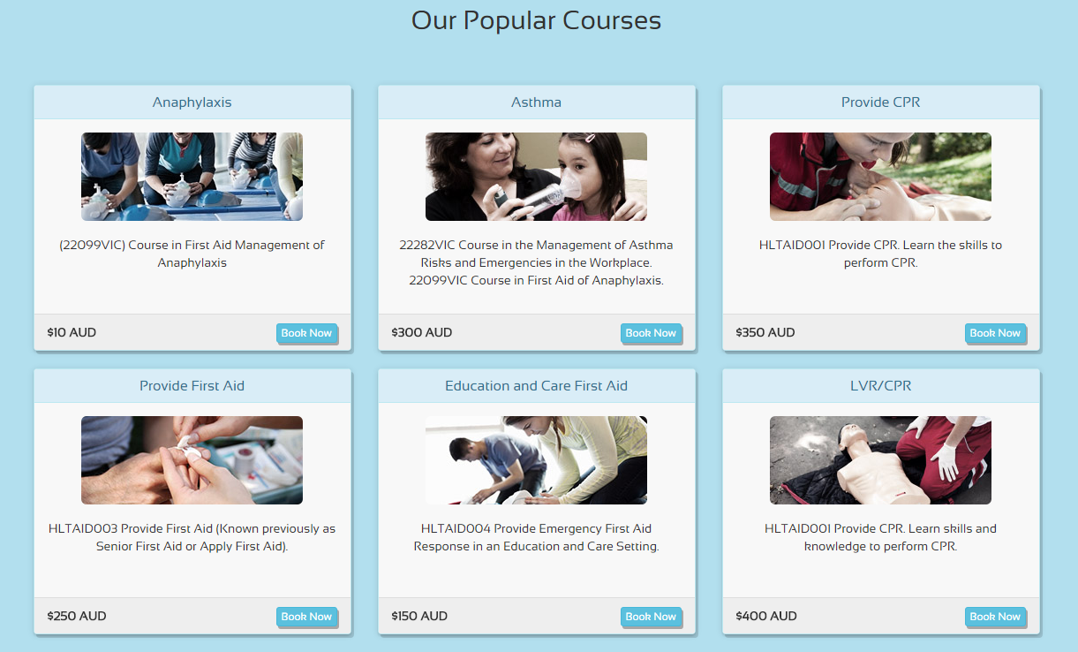

*(fig-3)*

## CHOOSE TIMETABLE

Once the user selects a desired course and confirms the eligibility, a preferred timetable is to be chosen to book the course. All the available timings will be displayed in the respective course pages. It involves the location of the course, course conduction date and time, available seats, course duration and price. The users can choose timetable only when there is at least one available seat.

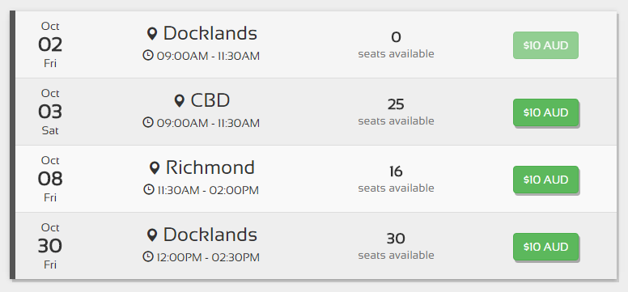

*(fig-4)*

## SEARCH TIMETABLE

If the user is unable to choose a timetable based on their availability in the course pages, a search box is available to search the courses based on either, course name, or course location, or course start time or course date. It can be accessed from any course page.

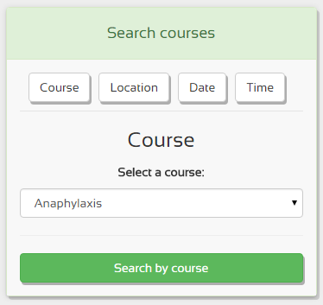**Steps to search**

* Navigate to any of the course pages
* Select any of the four available tabs1 in the search section
* Choose an option from the dropdown box
* Click Search by * to get the results
* Select desired search result to navigate to the course page to book the course

*(Fig-5)*

1 – Course name, Course location, Course time, Course date

## MAKE A PAYMENT

Once the users confirm all the course details and select a desired timetable, they can make the payment to complete the course enrolment. In order to make the transaction, the user needs to be logged in to the system. After logging in, the button beside the course timetable is to be clicked which directs the user to the PayPal system. PayPal system is being operated by PayPal INC and provides a very secure gateway to make the transactions.

**Steps to make Payment**

* Login to the system
* Select the course, fix a timetable and click ‘Book now’ (System redirects to PayPal)
* Login to PayPal account or complete transaction as a guest
* Provide card details and complete the transaction

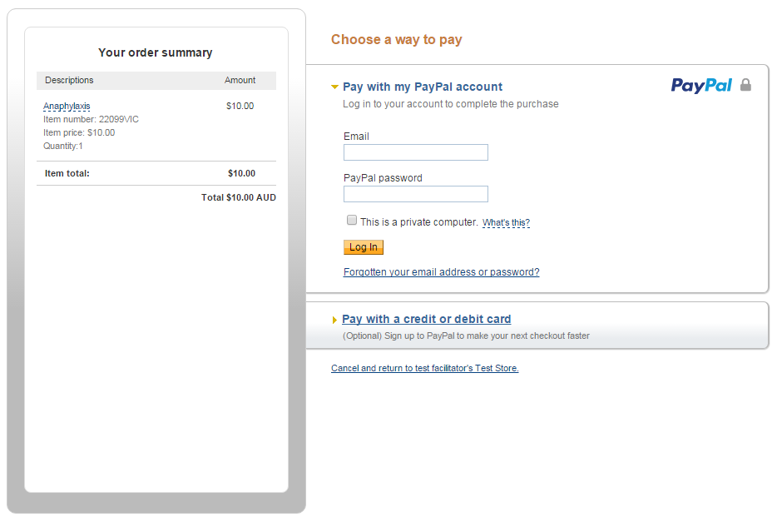

*(Fig-6)*

## MOODLE ACCESS

All the users who registered to the Vital Education System gets automatically registered to Moodle System. All the courses users enroll will be available in Moodle and can access the course contents online. Users can view only the courses they enroll. Username and password for the Moodle system will be same as Vital Education system. Users can participate in the course related activities and send/receive emails to and from the course tutors.

**Steps to access Moodle**

* Enroll to a course in Vital Education website (steps explained in the above sections)
* Login to Moodle (user id and password same as Vital Education website)
* Go to My Courses and select the enrolled course
* Access the course content.

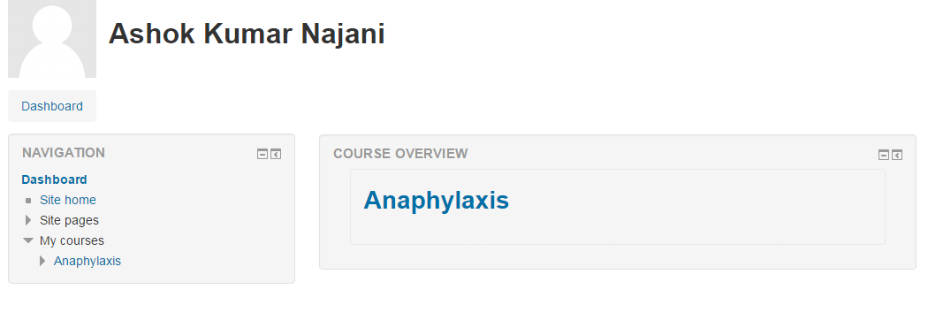

*(Fig-6)*

## UPDATE PROFILE

To maintain consistent user details, Vital Education website and Moodle system synchronizes the user details whenever changes are made in the profile. User can only change their profile details in the Moodle and those changes will be reflected in the Vital Education website.

**Steps to update Profile**

* Login to Moodle system
* Go to My Profile page
* Edit the user details
* Update the profile by submitting the form

## ACCESS BLOG AND COMMENT TO AN ARTICLE

Blog can be accessed by any user or guest who visits the website. Blog will be updated with latest articles about the news and important information which will be helpful for the readers. Users can comment on the articles they view. To add a comment, they need to provide a valid email address, user name and some comment 1. All the comments go to the admin panel for the admin confirmation. Only the comments that admin approve will be displayed in the comments block.

**Steps to access Blog and comment to an article**

* Open the Blog from navigation bar
* Select a desired article
* Provide necessary details 1
* Submit the form to post the comment.

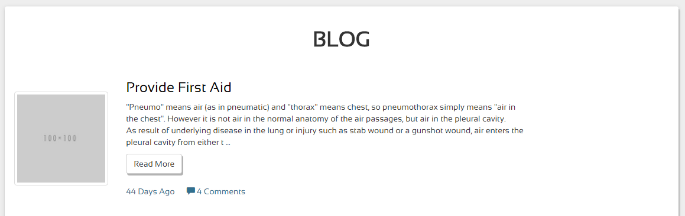

*(Fig-6)*

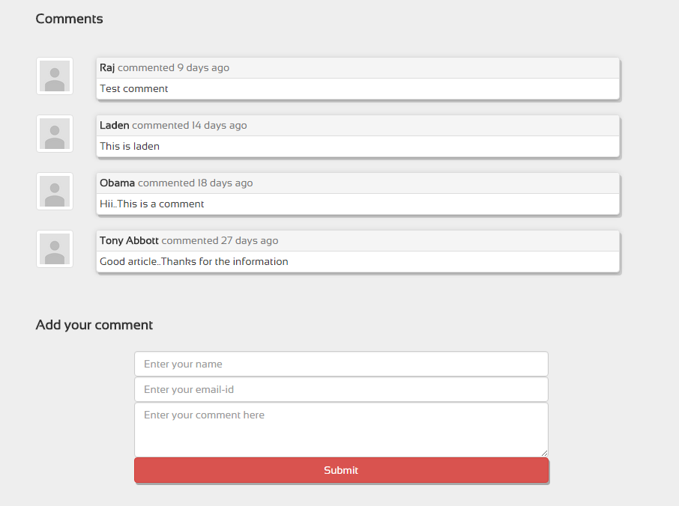

*(fig-7)*

1 – name, email, comment

## MAKE AN ENQUIRY

Users/Guests can make an enquiry about the courses or any other information they need from the contact us page. To send an enquiry to the admin, they need to provide their name, valid email address and the enquiry information. It normally takes 2-3 business days for the management to respond to the enquiries.

**Steps to make an enquiry**

* Go to contact us page through the navigation bar
* Fill in the necessary fields in the enquiry section
* Send the form to submit the enquiry.

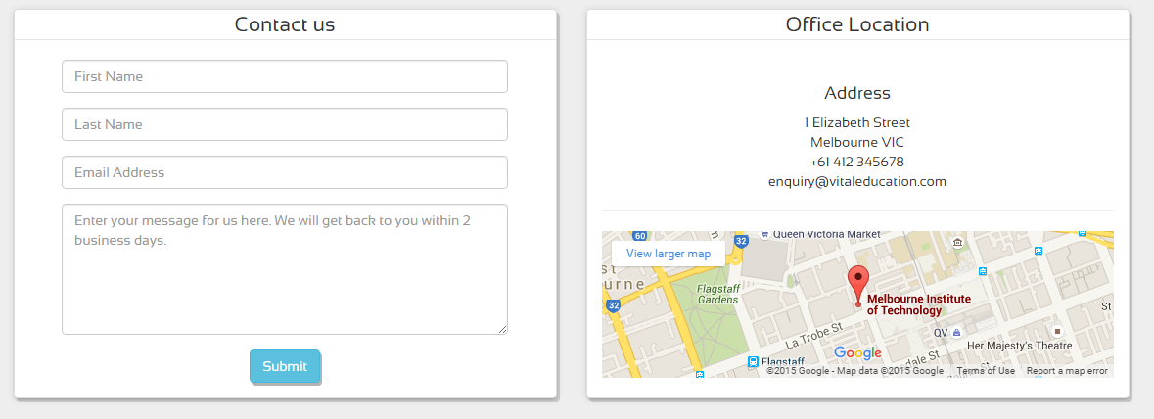

*(fig-8)*